Requirement Analysis
Customer Journey
Date | 02 October 2026
Student Name | Dhanyaa V S
Project Name | Automated Network Request Management in ServiceNow

1. Executive Overview & Workflow Pipeline
Modern enterprise IT landscapes demand secure, agile, and automated provisioning of network connectivity. This Customer Journey Map outlines the streamlined lifecycle of network service requests—including VPN access, firewall rule changes, and IP allocations—within ServiceNow. By uniting intuitive employee self-service with rigorous Flow Designer security approvals and zero-touch API orchestration, the platform reduces fulfillment latency from days to minutes while establishing immutable compliance records.
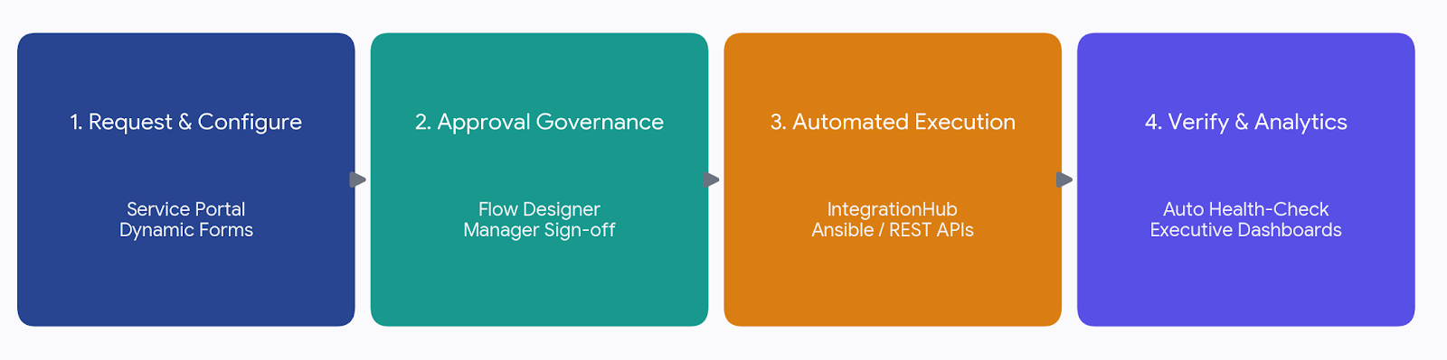
2. Consolidated Customer Journey Matrix
The 8 stages of the customer journey bridge user intent with automated platform capabilities. The table below details the interaction touchpoints, primary system objectives, and underlying ServiceNow engines:
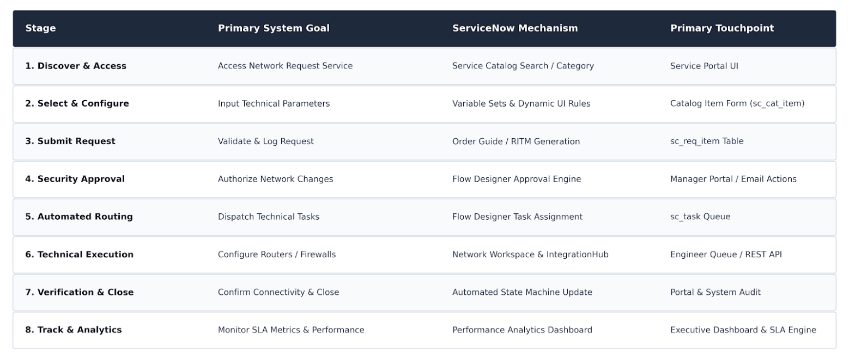

3. Platform Record Model &amp; Integration Architecture
ServiceNow maintains operational integrity through a relational three-tier record architecture. Incoming orders are captured under an overarching Request (sc_request), subdivided into individual Request Items (sc_req_item), and decomposed into granular technical fulfillment tasks (sc_task). This decoupled schema allows parallel orchestration across network firewalls, IPAM allocators, and directory services while preserving granular audit trails.
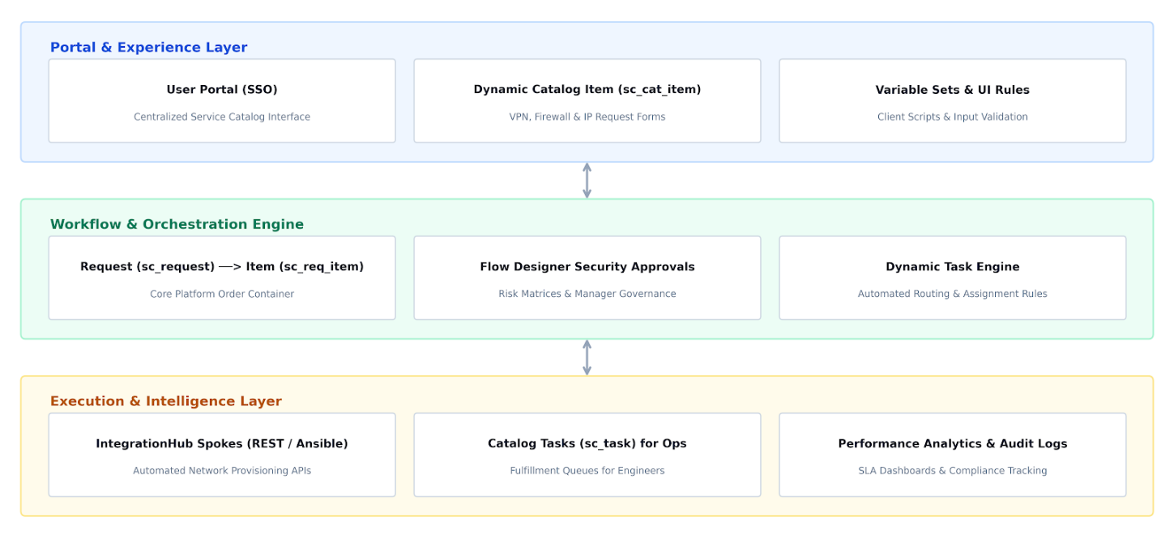

4. Core Stage Insights &amp; Optimization Opportunities
Intake & Parameter Validation (Stages 1–3)
The user journey begins with intuitive discovery in the Service Portal. Dynamic Client Scripts and regex validation prevent common configuration errors such as malformed CIDR subnets or port collisions. Auto-populating user metadata accelerates submissions while generating an immediate, trackable RITM number.
• Key Enhancement: Implement interactive subnet selection pickers and AI-powered search aliases to bridge non- technical requests with complex network catalog items.
Governance & Automated Routing (Stages 4–5)
Multi-channel approvals via email action buttons and manager workspaces streamline governance. Flow Designer dynamically evaluates risk policies to route low-risk requests automatically, while critical firewall changes trigger manager and Infosec reviews. Approved orders instantiate targeted sc_task records immediately.
• Key Enhancement: Introduce automated escalation rules and mobile approval widgets to prevent approval bottlenecks during off-hours.
Fulfillment, Verification &amp; Analytics (Stages 6–8)
Routine network configurations are pushed directly to firewalls and switches via Integration Hub REST spokes and Ansible playbooks, minimizing manual engineering touch time. Following automated ping and port validation, the state machine closes the ticket and updates Performance Analytics dashboards to evaluate SLA compliance and fulfillment trends.
• Key Enhancement: Embed a 24-hour user confirmation window and predictive SLA breach alerts to resolve edge connectivity issues before hard closeout.

